Gyroscopic Stabilization Of A Stationary Unmanned Bicycle
Jason M. Gallaspy John Y. Hung∗
Dynetics, Inc. Electrical & Computer Engineering Department
Huntsville, AL Auburn University
U.S.A. 200 Broun Hall
Auburn, AL 36849-5201, U.S.A.
fax: (334) 844-1809
e-mail: j.y.hung@ieee.org

Abstract This paper presents a method for stabilizing an unmanned bicycle in the upright position. Nonlinear dynamics of the bicycle and control gyroscope are modeled using Lagrange’s method. Then, a linear approximate model is developed to design a controller to stabilize the bicycle. An 8-bit fixed-point microcontroller computes control commands to actuate the gyroscope gimbal axis, thus producing a restoring torque on the bicycle frame. Simulations using MATLAB/SIMULINK are analyzed, and experimental results are summarized. Finally, recommendations for further work are given in the concluding remarks.

I. Introduction

History
Invented in the mid-1800s, the spinning mechanical gyroscope has been widely applied and continues to fascinate scientists today. As a sensor, the gyro has a long history of application in navigation systems, and more recently in virtual reality equipment and wireless remote pointers for computers. The gyro has been applied as a controller in the steering systems of ships, planes, and torpedos. In these applications, the important gyroscopic characteristic being used is rigidity in space, i.e. the spinning gyroscope maintains it orientation in space.
The gyroscope can also function as an actuator by using the precession characteristic. Here, torque is applied to an axis normal to the spin axis, and the gyroscope reacts by turning on a third axis (precession axis) orthogonal to both the spin and torque axis. If the precession axis is attached to a frame, then the resultant torque acts upon the frame. Gyroscope have been used for satellite attitude control and dampening ship roll dynamics. Crabtree’s 1914 book, “Spinning Tops and Gyroscopes” reports Shilowsky’s idea to maintain a monorail train in the upright position.
The objective of the present research is to investigate the dynamics governing a bicycle and to determine if gyroscopic stabilization is possible. A gyroscope in a single-axis gimbal frame is mounted on the bicycle so that the spin axis is upright (vertical) and the gimbal axis is parallel to the bicycle axles. Control torque is applied to the gimbal axis, so the resulting precession axis is parallel to the bicycle’s lean axis. Controller design and implementation draws upon several areas of Electrical Engineering: continuous and discrete-time system analysis, embedded microcontroller design, power electronics, and electric machine control. Therefore, the bicycle stabilization problem is an excellent example of mechatronic design.

Literature Review
Several papers are reviewed to gain an understanding of previous work in the field of bicycle stabilization. The idea for this project is motivated by the 1968 work of Ross and Hung [1], who demonstrated a method for stabilizing a bicycle using a gyroscope. That system used analog control electronics and the design model assumed nonzero forward velocity, though the authors successfully demonstrated stabilization at zero velocity. More than twenty years later, Klein presented a method to achieve the upright stability of a moving bicycle solely by steering input [2]. More recently, Getz and Marsden [3], and Getz [4]-[5] develop two-input stabilization strategies, using the steering angle and rear wheel torque as inputs to stabilize the bicycle. Nonzero forward velocity is common to all of the recent works [2]-[5]; bicycle stabilization at non-zero velocity is similar to what a human does when riding a moving bicycle.
In the present work, the bicycle is stabilized at zero forward velocity, a task that is extremely difficult for the human rider. In addition, microcontroller technology is used for controller implementation.

II. System Hardware Description
Three elements comprise the system plant: the bicycle, a control gyroscope mounted in a single-axis gimbal frame, and DC gearmotor. The gearmotor shaft is attached to the gimbal axis of the control gyroscope. Spin axis of the control gyro is vertical; gimbal axis and the gyro spin axis are orthogonal. The gimbal frame of the gyro is attached to the bicycle frame so that when the bicycle is upright, the line connecting the earth contact points is perpendicular to both the gimbal axis and the gyro spin axis. When commanded by the controller, the DC gearmotor torques the gyro about the gimbal axis, creating a precession torque. The precession torque of the gyro is exerted on the bicycle frame. When properly controlled, the precession torque should turn the bicycle towards the upright position. Photographs showing the top view and side view of the bicycle and control system hardware are shown in Figure 1 and Figure 2.
The system controller can be seen in Figure 1, and it consists of hardware and software elements that provide a means to control the system. A small gyroscope with a built-in optical encoder is used to measure bicycle leaning angle. Measured angular displacement is processed by an Motorola MC68HC11 8-b microcontroller. The control algorithm output is then used to generate a pulse-width-modulated (PWM) waveform. An H-bridge power amplifier is driven by the PWM waveform to drive the DC gearmotor. The 68HC11 microcontroller also generates switching signals for the three-phase inverter that drives the spin motor of the large control gyroscope (the gyro spin motor is a three-phase hysteresis type machine).

III. SYSTEM MODELING
A block diagram of the control system is shown in Figure 3. The plant consists of the bicycle, control gyroscope and DC gearmotor, as well as the gains of the H-bridge amplifier and sensing gyroscope. A model of the combined dynamics of the bicycle, control gyro and DC gearmotor is presented in this section.

Bicycle / Gyro Dynamics
As previously described, the system uses a dc motor to torque the spinning gyro about a gimbal axis, thus producing a precession torque on the bicycle frame. The exact relationship between these interactions can be determined by deriving equations to describe the mechanical and electrical dynamics. The system dynamics are modeled by a set of coupled, nonlinear differential equations. After linearization, these equations are then formulated into linear state-space and transfer function models, with dc motor voltage as the input and the bicycle leaning angle as the output.
First, a model is developed that relates the leaning angle of the bicycle to the input torque on the gyro (τ_{g}). Although this torque is applied by the DC geamotor, it is simply assumed for now to be some known function of time. The bicycle and control gyroscope are considered two separate rigid bodies that are kinematically constrained. Additionally, it is assumed that the only bicycle motion is from leaning and that the gyroscope spin speed is constant. A diagram of the system mechanical components, as well as the coordinate system and modeling nomenclature are shown in Figure 4. Parameter values are listed in Appendix A. Lagrange’s method is used to derive the equations of bicycle and gyroscope motion, yielding:
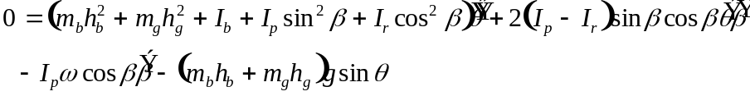 (1)
(2)
Notice that these equations are essentially summing torques on along the θ and β axes, respectively. Also recall that the torque input to the gyro (τ_{g}) is produced by the dc motor.

Incorporating motor dynamics
The DC gearmotor is mounted inline with the gyro to provide a torque (τ_{m}) in the β direction. This same torque was previously denoted τ_{g}. Also, note that Ω corresponds to. Taking into account the motor dynamics, the three plant equations are given by:
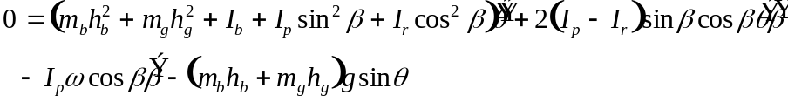 (3)
(4)
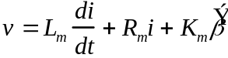 (5)
These three plant equations completely describe the plant dynamics under all operating conditions. The model is quite complex, being a set of fifth-order, coupled, nonlinear differential equations. An analysis of each term will help to better understand the plant as a whole and how simplifications such as linearization will affect the model.
The first plant equation (3) essentially states that the sum of all torques on the bicycle about the θ axis equals zero. Therefore, each term represents a torque, arising from one of many different effects. The first term is an inertial term due to the masses of the bicycle and gyro; the inertia is multiplied by the angular acceleration . The second is a Coriolis term, since it involves the product of the two rates and . These terms arise when dealing with systems having multiple rotating reference frames. The third term is a gyroscopic effect that indicates that gyro velocity about β will produce a torque on the bicycle. Note that this torque is proportional to I_{p}ω, the angular momentum of the gyro (with no bicycle or gyro motion). The last term describes the torque due to gravity.
The second plant equation (4) sums the torques about β, setting them equal to the input torque from the dc motor (K_{m}i). The first term on the right hand side is simply an inertial term involving the angular acceleration . Next is a torque term due to the dc motor friction. The third term is a centripetal term that indicates how the gyro is torqued due to the angular velocity of the bicycle. Note that for a body with I_{p} = I_{r}, this term would vanish. The final term is again a gyroscopic term, which works in reverse from the previous one to show that an angular velocity about θ will produce a torque on the gyro.
The final plant equation (5) models the electrical dynamics of the DC gearmotor. Variables v and i represent motor input voltage and winding current, respectively. Parameters R_{m}, L_{m}, and K_{m} are the motor winding resistance, winding inductance, and motor constant.

Linear approximate model
A linear approximation of the plant model about the upright equilibrium point can be represented in state variable form. Choose the state vector as:
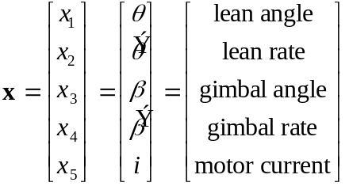 (6)
The system matrix A and input matrix B are given by:
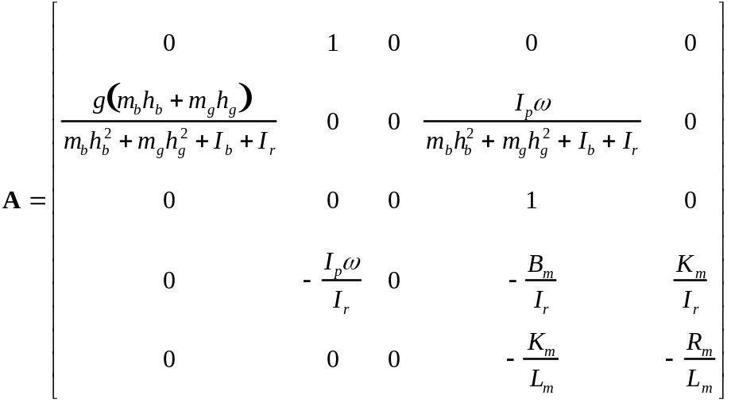 (7)
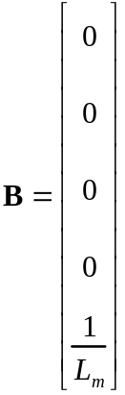 (8)
The column of zeros in center of the A matrix indicates that the linearized approximate dynamics around the upright position do not depend on x₃, the gimbal angle. Therefore, a fourth-order representation can be used as the linear system model. Redefining x as
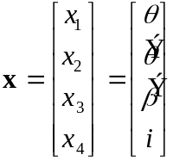 (9)
the system matrices reduce to
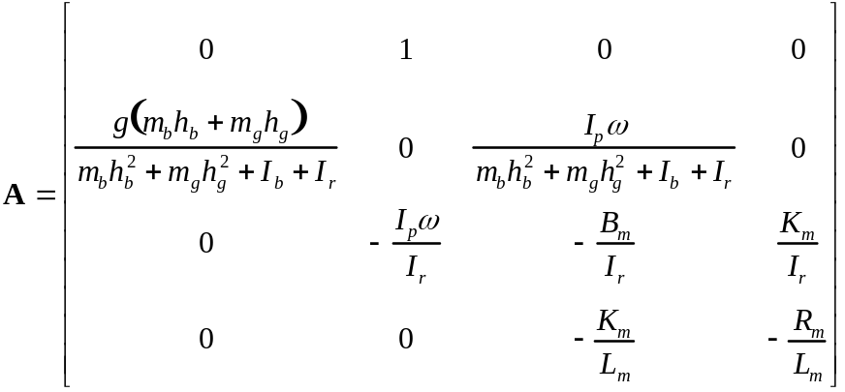 (10)
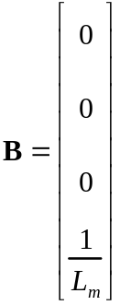 (11)
A disadvantage of the model reduction is that gimbal angle β is no longer available as a state.
Using measured values (see Appendix A), the system matrices become
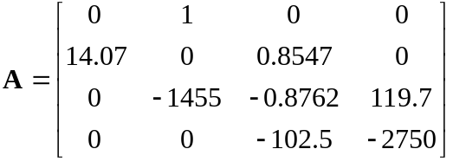, 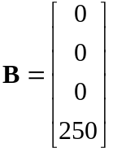 (12)
Defining the plant output to be the lean angle θ, the remainder of the state variable description is
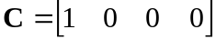, 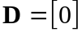 (13)
Computing the transfer function from the state variable realization (A, B, C, D) yields
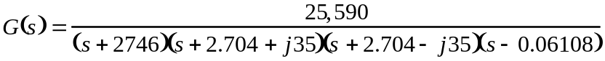 (14)

Lean Angle Sensor
A small gyroscope is used to measure the leaning angle of the bicycle. An optical encoder inside the gyro housing senses the lean angle, and the sensor gain is K_{s} = 5 counts per degree. The encoder has finite resolution, however, so the sensing resolution is limited to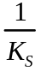. Therefore, the lean angle sensor can determine the true position of the bicycle angle within one-fifth of a degree. This is mathematically represented by
(15)
where the fix() function rounds its argument to the nearest integer toward zero. In most control systems, small sensor quantization may be insignificant. Such is not the case for the bicycle system, where finite resolution greatly impacts the system behavior. Consider the situation where the bicycle is initially at an angle greater than one-fifth of a degree. Under closed loop control, the bicycle will move towards an upright position until it is within one-fifth degree of the vertical plane. At this point, the sensor indicates that the bicycle is upright, generating a zero output. The controller output will become zero, but since the bicycle is not yet perfectly vertical, a greater leaning motion will result. In theory, the lean angle settles about some nonzero displacement. Consequently, a constant torque due to gravity is exerted on the bicycle. Examining the lean angle dynamics (1) reveals that overcoming this torque involves a nonzerothat can only be produced by constantly rotating the control gyro. Eventually, the gyro angle becomes sufficiently large to invalidate the linear model. Even using a perfect, continuous sensor does not solve the problem, since quantization effects are introduced in the analog-to-digital conversion stage of the digital controller. A method of accounting for this undesirable quantization effect is discussed in a later section.

IV. CONTROL SYSTEM DESCRIPTION
The approach for designing the system controller is based on classical control system design, followed by compensation for the sensor quantization problem described earlier.

Continuous-Time Design
The continuous compensator is designed using a root locus technique. Although the gyro gimbal angle β is not a controlled variable, the controller should still ensure that it is bounded. This is necessary for two reasons: the gyroscope has physical limits on its rotation, and the linear design model assumes a small gyro angle.
From linear models for the plant and sensor, the system open loop function H(s) is
(16)
Note that this system is type zero, so steady-state error will always exist for step inputs. As mentioned in the sensor discussion, any nonzero steady state value of the bicycle angle would force the gyro to continuously rotate. To avoid this, a controller that increases the system type is necessary. This will ensure that θ is zero at steady state, resulting in a bounded β.
A compensator of the form
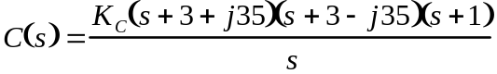 (17)
yields the root locus diagram shown in Figure 5. The compensated system will be stable for sufficiently large controller gain K_{C}.

Controller discretization
The controller is converted to discrete-time form using the matched z-transformation. In addition, two fast “instrumentation” poles (z=0) are added. Controller gain K_{c} is fine-tuned by trial and simulation. The discrete-time controller is represented by:
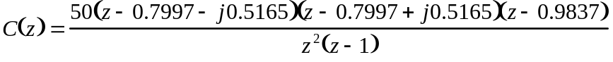 (18)
This compensator is implemented as a difference equation using the Motorola 68HC11 microcontroller.. Since the microcontroller can only represent numbers as integers, an estimate of C(z) using integers is needed. Multiplying the numerator and rounding yields:
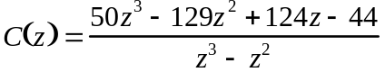 (19)

Sensor Zero Eliminator
The controller must also counteract the sensor quantization. Recall that quantization cause the sensor output to indicate zero when lean angle θ is very small, though nonzero. As described earlier, the control gyro will eventually saturate while trying to overcome the small quantization error. To account for this, the control program removes the zero level from the sensor output. When the sensor output is zero, the control program will use the most recent nonzero sensor output. Consequently, the control system will continue to apply torque to the bicycle, even though the sensor registers zero. Eventually, the bicycle will move past its upright position and begin falling in the opposite direction. The disadvantage of this compensation method is that it introduces an oscillation about the upright position, albeit a small one.

V. ANALYSIS OF COMPUTER SIMULATIONS
Computer simulations are performed to test the behavior of the controlled system. Models of the equations that govern the dynamic behavior of the system are constructed in SIMULINK. The control system behavior is simulated over a 10 s interval. The bicycle frame is initially leaning at an angle of one degree, with all other initial conditions equal to zero. Figure 6 shows the bicycle angle over this interval. The bicycle quickly recovers, and begins oscillating about its upright position of θ=0. As expected, the magnitude of this oscillation on the order of one fifth of a degree.
The simulated lean angle sensor output is shown in Figure 7. Note that the zero eliminator algorithm is included in the simulation, so the output nevers settles to zero. This plot shows that the oscillation is confined to within ±1 count of zero, as desired.
The gyro gimbal angle β also exhibits the oscillation (Figure 8). As stated earlier, the oscillation is a by-product of the controller modification used to overcome actuator saturation. This plot shows that the controller controls β to be bounded in steady state operation. In addition, the maximum excursions of the signal are within limits imposed by the physical system.
Successive simulations with different initial conditions resulted in similar waveforms. An important effect seen is that a large initial bicycle angle causes the gyro angle to move beyond its physical limits. This indicates that experiments should be conducted with the bicycle angle initially as close to zero as possible for best results.

VI. SUMMARY OF EXPERIMENTAL RESULTS
With the components mounted, the stability of the closed loop bicycle system was tested. Figure 1 shows a closer view of the assembled components mounted on a platform attached to the bicycle seat frame. The bicycle, control gyro, DC gearmotor, lean angle sensor, motor drive electronics and microcontroller can be clearly seen in this image. The control gyroscope is on the left-hand side, and the gearmotor is at the bottom of the photograph. The lean angle sense gyroscope is just above the gearmotor. Output signals from the sense gyro are transmitted via a coiled cable to the signal conditioning circuits on the larger of two white breadboards. The microcontroller board straddles the two white breadboards. Drive electronics for the gearmotor and three-phase spin motor of the control gyro are on the smaller white breadboard. A view of the complete bicycle with the design engineer is shown in Figure 9.
A set procedure is used to begin an experimental run. First, the system is instructed to begin executing its control program, although it does not actually generate control outputs to close the loop. The first task is to drive the gyro spin motor to synchronous speed. Once this speed is reached, the bicycle is positioned as close to perfectly upright as possible. An external signal triggers the controller to initialize the sensor output to the zero reference level. Finally, closed loop control is initiated when the microcontroller send control outputs to the H-bridge that drives the DC motor.
Due to limited memory space of the microcontroller, it was not possible to record experimental data. Therefore, only a description of performance is possible at this time. The bicycle system is able to stabilize itself for brief periods of time, but the motion has oscillations that are slightly larger than those predicted by the simulations. The physical limits on gyro gimbal motion become a problem over time. If the gimbal mechanical limit is reached, the bicycle immediately falls away from the upright equilibrium state.

VII. CONCLUSIONS
System modeling, dynamic analysis, controller design, and microcontroller implementation of a control system to stabilize an unmanned bicycle have been presented in this paper. The work is unique from known works in several ways. First, controller implementation is achieved with an inexpensive, 8-bit, fixed-point microcontroller. Second, the controller stabilizes the bicycle at zero forward velocity. The control system is able to stabilize the bicycle in experiments, but improved performance is desirable.

Recommendations for future work
The various hardware limitations of the system are probably the largest factors contributing to the reduced stability margins.
- Motor deadzone – Experimental analysis of the gyro gimbal motor reveals a significant deadzone. The effect of deadzone has not be pursued in this study, so compensation methods remain an open issue.
- Microcontroller – When compared to a personal computer or digital signal processor, the 68HC11 microcontroller is limited in its arithmetic capability. A more powerful controller using 16-bit arithmetic and floating point math would reduce errors introduced by coefficient quantization in the compensation routine. An implementation based on a digital signal processor (DSP) controller will also reduce roundoff and quantization errors, but the research objective was to examine the feasibility and performance limitations imposed by a microcontroller implementation.
- Position sensor – Although the argument in Section III states that sensor quantization effects will never be perfectly overcome, a sensor with better resolution could conceivably make the adverse effects less noticeable.
Other recommendations involve aspects of the controller design.
- State feedback approach – The controller was designed assuming only feedback of the bicycle angle θ. A controller using full state feedback and state estimation can be explored. This approach may have the added benefit of controlling the gyro gimbal angle, thus preventing it from reaching the physical limits (saturation).
- Robust controller – The accuracy of model parameters remains an open issue. Some parameters (bicycle moment of inertia, gyroscope moment of inertia) are very difficult to measure accurately. For example, the gyroscope rotor is inaccessible due to its hermetically sealed construction. A more robust controller, such as a sliding mode controller, may be better suited to adequately account for these uncertainties.

VIII. REFERENCES
[1] C.H. Ross, J. C. Hung, “Stabilization of an Unmanned Bicycle,” Proc. IEEE Region III Convention, 1968, pp. 17.4.1-17.4.8.
[2] R.E. Klein, “Using Bicycles to Teach System Dynamics,” IEEE Control Systems Magazine, Vol. 9, No. 3, Apr. 1989, pp. 4-9.
[3] N.H. Getz and J.E. Marsden, “Control for an Autonomous Bicycle,” Proceedings of IEEE Int’l Conf. on Robotics and Automation, pp. 1397-1402, Nagoya, JAPAN, May 1995.
[4] Neil H. Getz, "Control of Balance for a Nonlinear Nonholonomic Non-Minimum Phase Model of a Bicycle", American Control Conference, Baltimore, July 1994.
[5] Neil H. Getz, "Path Tracking with Balance for a Nonlinear Nonholonomic Non-Minimum Phase Model of a Bicycle", 34th IEEE Conference on Decision and Control, New Orleans, December 1995.

APPENDIX A: Model Parameters and Values
Bicycle mass 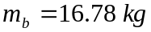
Bicycle upright c.g. height 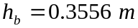
Bicycle moment of inertia about ground contact line 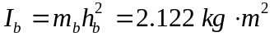
Gyro mass 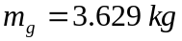
Gyro upright c.g. height 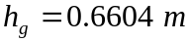
Gyro radius 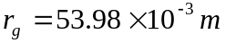
Gyro height 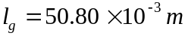
Gyro polar moment of inertia about c.g. 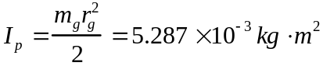
Gyro radial moment of inertia about c.g. 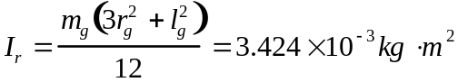
Gyro spin speed 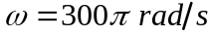
Gravitational acceleration 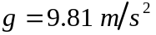
DC Motor winding inductance 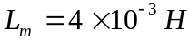
DC Motor winding resistance 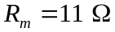
DC Motor friction constant 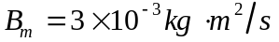
DC Motor torque / voltage constant 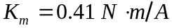
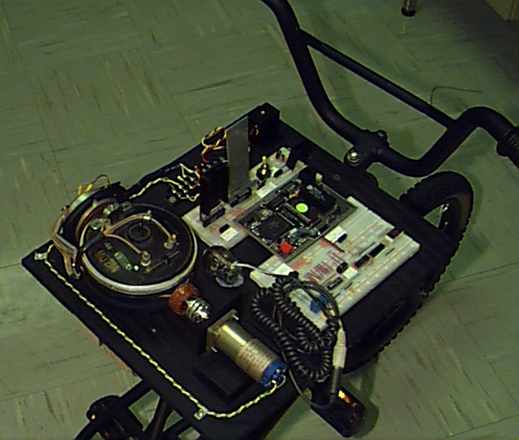
Figure 1. Overhead view of bicycle and controller.

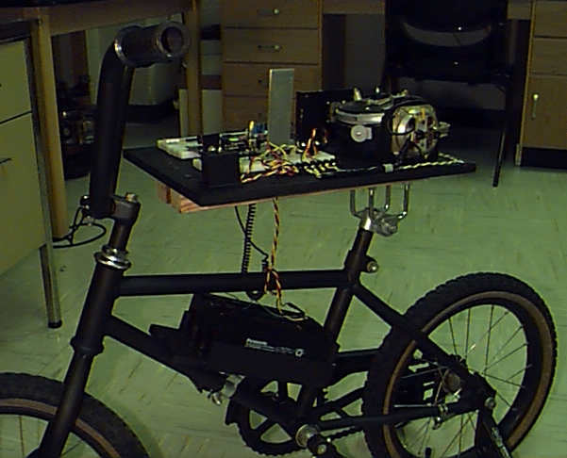
Figure 2. Side view of bicycle, controller, and batteries.

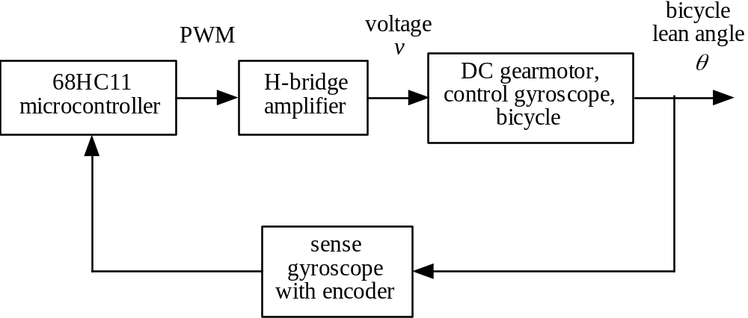

Figure 3. Control system block diagram.

Constants:
h_{g} cosθ
h_{b} cosθ
m_{b}, I_{b}
m_{g}, I_{p}, I_{r}
ω
β
θ
R_{m}, L_{m}, B_{m},
K_{m}, i, v
m_{b} – bicycle mass
h_{b} – bicycle c.g. upright height
I_{b} – bicycle moment of inertia about pivot
m_{g} – gyro mass
h_{g} – gyro c.g. upright height
I_{p} – gyro polar moment of inertia about cg
I_{r} – gyro radial moment of inertia about cg
ω – gyro speed
R_{m} – dc motor resistance
L_{m} – dc motor inductance
B_{m} – dc motor friction
K_{m} – dc motor torque/voltage constant

Variables:
θ – bicycle lean angle
β – gyro gimbal angle
i – dc motor current
v – dc motor voltage

Figure 4. System Mechanical Diagram

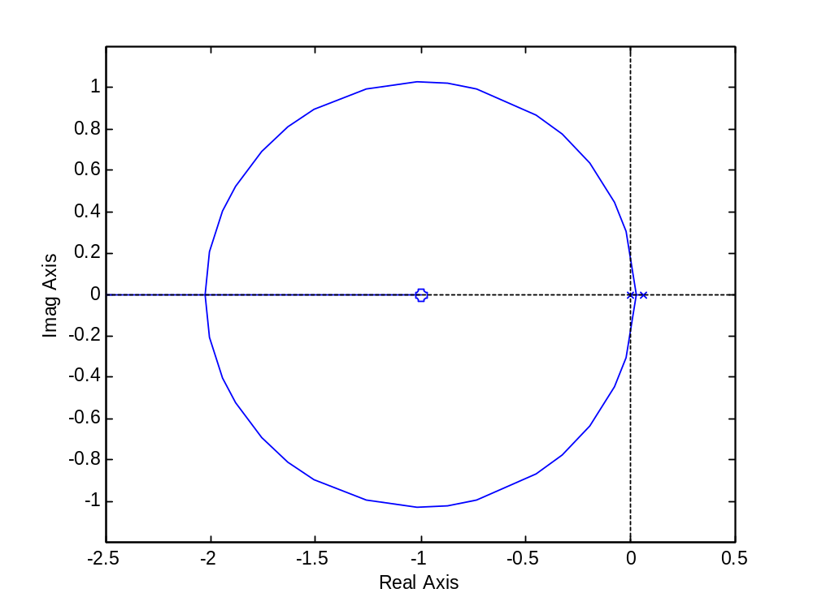

Figure 5. Compensated System Root Locus (zoom)

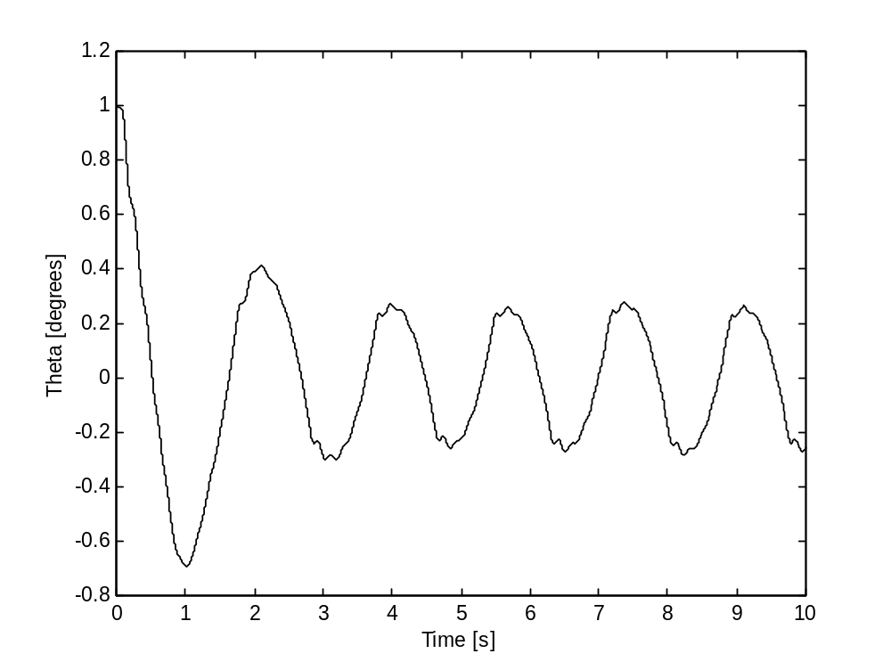

Figure 6. Bicycle Lean Angle (simulated)

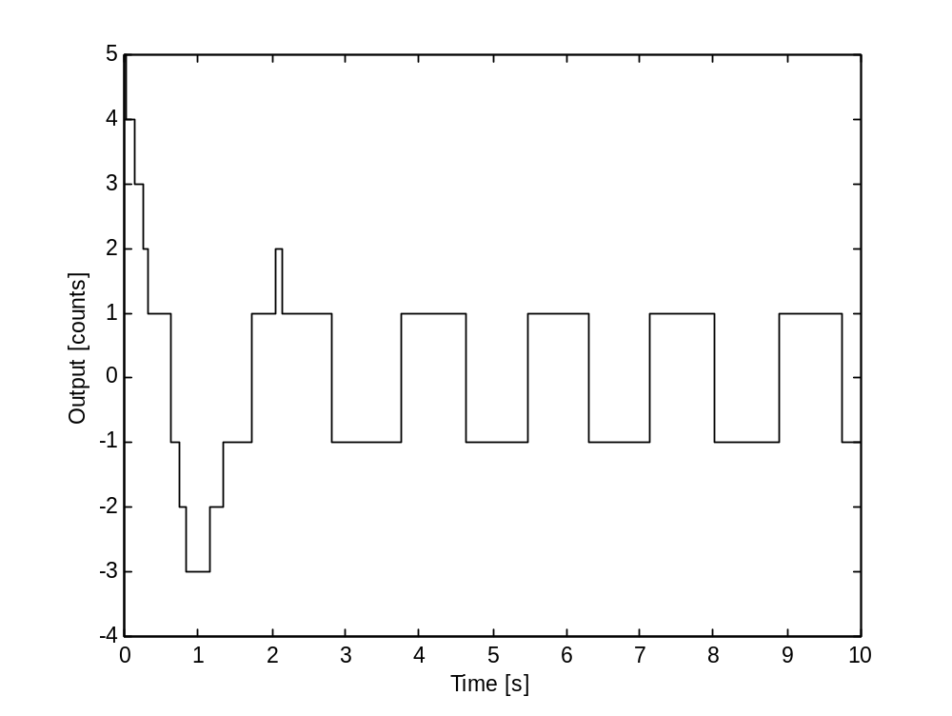

Figure 7. Sensor Zero Eliminator Output (simulated)

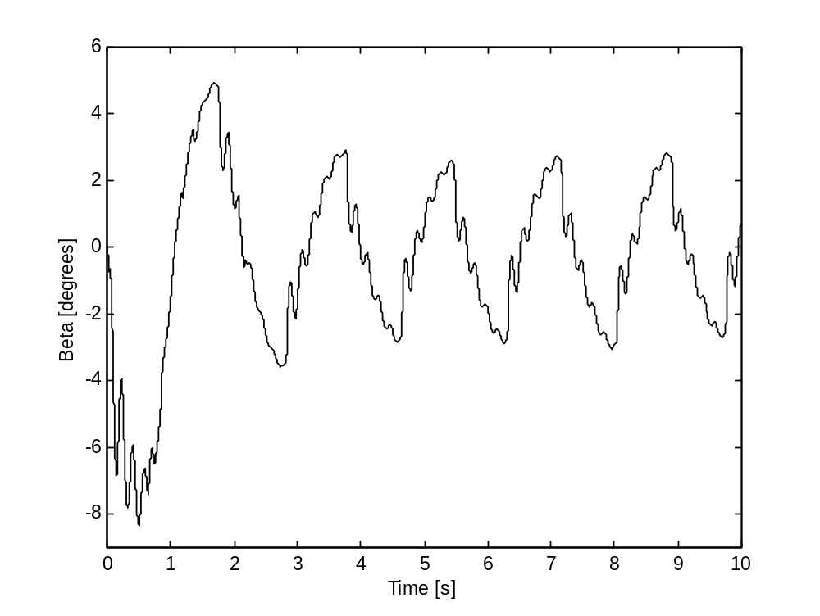

Figure 8. Gyro Gimbal Angle (simulated)

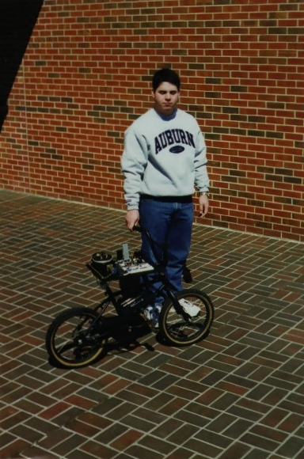
Figure 9. Self-stabilizing bicycle with design engineer.

corresponding author.

